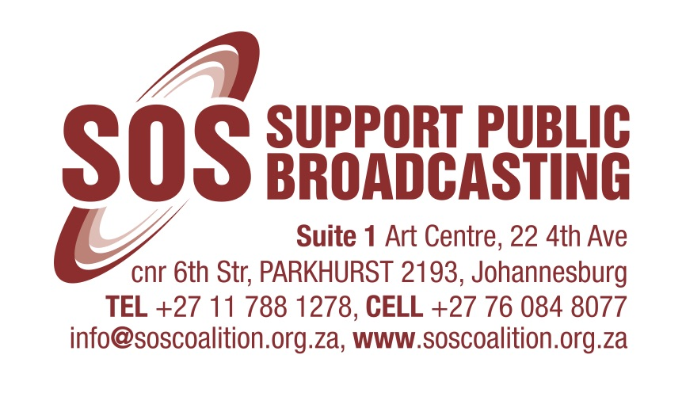
SOS Welcomes Western Cape High Court Judgment Setting Aside Motsoeneng Appointment as Irrational and Unlawful

27 November 2015

The SOS Coalition heartily welcomes the judgment handed down by the Western Cape High Court, setting aside Hlaudi Motsoeneng’s permanent appointment as SABC COO on the basis of irrationality and unlawfulness. We have consistently maintained since the release of the Public Protector’s report, When Governance and Ethics Fail, last year that the SABC Board must direct itself in line with the laws of this country and see through the implementation of her recommendations.

Instead, and with the full backing of the Minister of Communications as well as the deliberate inaction of Parliament, the Board deemed it fit to ignore the recommendations altogether and treat the Public Protector with contempt. The SABC Board and Minister Muthambi even went as far as commissioning a paid-for report, by their own attorneys and used that as the basis to clear Motsoeneng of wrong-doing and permanently appointment him as COO, which is inimical to their respective duty and oaths to serve the people of this country in the public interest, being public representatives.

It comes as no surprise to us that the Minister of Communications and SABC Board have declared their intention to continue to defend the indefensible and appeal this judgment, further wasting the public funds allocated to the loss-making SABC. This is most reprehensible and must be condemned in no uncertain terms.

Instead of wasting limited public resources delaying the inevitable and exposing our national public broadcaster to further scandal, disgrace and erosion, the SABC Board and Minister of Communications must do the right and proper thing: implement the recommendations of the Public Protector’s report fully, speedily, and in good faith.

The SOS Coalition has launched its own case regarding the procedures followed that resulted in the unlawful appointment of Mr Motsoeneng which looks at the legality of the Minister’s involvement in all such appointments and not just Mr Motsoeneng’s. We are of the view that our case has been bolstered by both the SCA’s and the WC High Court’s judgments on Mr Motsoeneng’s appointment and we look forward to having these critical legal issues settled in order to better protect the public and the public broadcaster in relation to the appointment of its senior management and directors.

The SOS Coalition represents a broad spectrum of civil society stakeholders committed to the broadcasting of quality, diverse, citizen-orientated public-interest programming aligned to the goals of the SA Constitution. The Coalition includes a number of trade union federations including COSATU and FEDUSA, a number of independent unions including BEMAWU and MWASA; independent film and TV production sector organisations including the South African Screen Federation (SASFED); a host of NGOs and CBOs including the Freedom of Expression Institute (FXI), Media Monitoring Africa (MMA), SECTION27 and a number of academics and freedom of expression activists.

For more information contact:
Sekoetlane Jacob Phamodi
Coordinator
076 084 8077

